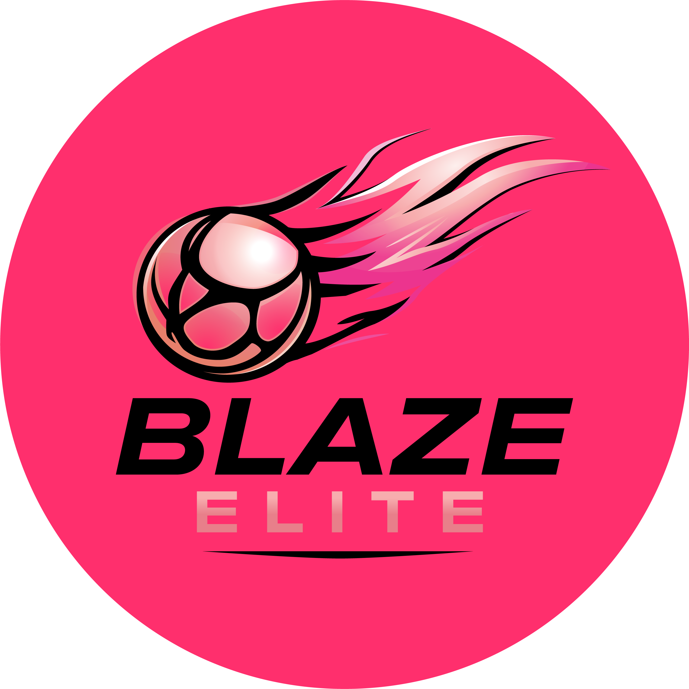

Social Media Policy
Blaze Elite Netball Club

1. Purpose
This policy sets out how Blaze Elite manages its own official social media channels, separate from the conduct expected of athletes, parents and volunteers set out in the relevant Codes of Conduct, and alongside England Netball's own national Social Media Policy (see our Adoption of England Netball Policies document).

2. Official Channels
Blaze Elite's official social media channels are managed by the Committee. No other individual is authorised to post on behalf of the club.

3. Content Standards
- Content will be positive, accurate and appropriate for a junior sporting environment.
- Team and athlete performance may be featured, including team spotlights, in line with the club's commitment to giving athletes a platform to be recognised.

4. Consent & Images of Athletes
Athletes are only featured in photography, video or social media content where parental consent has been given via the Athlete Registration & Annual Consent Form.

5. Moderation
Comments on official Blaze Elite channels are monitored, and any discriminatory, abusive or inappropriate comments will be removed.

